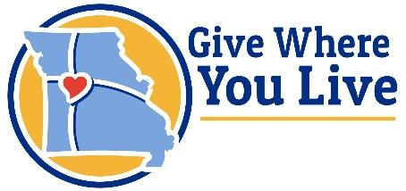United Way of Pettis County
501 E 17th St
Sedalia, MO 65301
(660) 826-2980
Rachelle.simon@spcuw.org
www.spcuw.org

OFFICERS
President: Tonja Hascall
Vice President: Kim Birdsong
Secretary: JoAnn Martin
Treasurer: Haleigh Mullins
President Appointee:
Anna Berkbigler
BOARD OF DIRECTORS
Chad Jamerson
Autumn Porter
Garrell Pierce
Bill Imahuser
Kirstin Sopko
Tehya Huffman
David “Jake” Jacobsmeier
Campaign Committee
Noah Kelley
Lauren Anderson

Staff
Rachelle Simon,
Executive Director

Dear Community Member,
United Way of Pettis County (UWPC) connects all sectors of society to create positive social change. Advancing the common good is less about helping one person at a time and more about changing systems to help the marginalized. In 2024, UWPC served 12,346 individuals (28% of the population) in Pettis County through UWPC programs and partner programs.
We support the great work being done in the community, focusing on lasting change, addressing long-term and emerging problems, and filling current gaps in resources. We support programs such as 211; both statewide and local United to Help Our Neighbors (UHON); Day of Action; and the Needs Based Fund. In addition to UWPC programs, we fund local nonprofit programs as well. In 2025, we are funding 20 local nonprofits, including 16 funded partners and 4 additional one-time grants. A 2024 statewide UHON program helped with rental, utility, childcare, and transportation assistance for 57 households with total assistance of just over $59,000. As we saw this much-needed program ending, we decided to apply for a grant to continue a local version of it. Through funding received in Oct 2024, we were able to prevent 16 families from being homeless or assist them in obtaining stable housing with total assistance of $10,100. On June 21, 2025, 275 volunteers worked on 35 projects that benefited over 115 individuals as part of our annual Day of Action. In 2024 we started the Needs Based Fund, providing financial assistance that is not already met by another organization or resources. In 2024, we assisted 32 households with total assistance of over $12,300. We continued this in 2025 and as of September, United Way’s Needs Based Fund served 167 households with total assistance over $59,000.
We are a trusted platform for creating community solutions and collaborating on local areas of need. In April 2025 we joined others to assist in opening Mercy Services United (MSU). MSU is a collaboration between agencies to meet with clients and provide programs, support, and resources. The space is a walk-in hub providing an initial holistic needs assessment for clients. Social service professionals from 8 nonprofit organizations assist clients to identify and address challenges keeping them from thriving. MSU also has laundry, shower, mail, and communication services to provide day-to-day amenities for those in need. As of Sept, MSU has served over 375 clients. Another collaborative project is our ToRCH (Transformation of Rural Community Health) Environmental Modifications services, which improve living conditions of those on Medicaid. As of Aug 2025, we have served 47 households with over $109,000 in environmental modifications to improve the health and safety of their homes.

We are local people, bringing together local resources, to create local solutions. 99% of what comes into the United Way of Pettis County stays in this community! By supporting UWPC, you are helping your neighbors to meet their immediate needs now, AND helping to improve our community structures so people can thrive in the future.

There are several convenient ways to support our mission:
- Support via your Business by inviting your employees to give back by running a workplace campaign via employee payroll deductions or credit card deductions OR organizing a fundraiser at work.
- Support via the iPledge or DineUnited - your business or restaurant gives directly to support UWPC through making a pledge for 2026.

United Way of Pettis County board, staff and volunteers thank you for your time and
consideration of supporting the United Way 2026 Campaign.

As you Give Where You Live, together we can do so much to better our community!

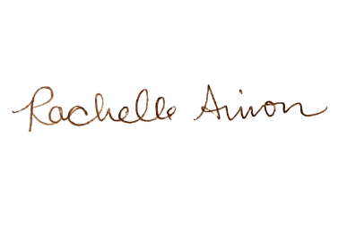
Thank you,

United Way of Pettis County Board of Directors
Rachelle Simon, Executive Director

